DocNo: 001.D.1:1

Software Architecture Document
Version 1.0

Group Member:
孔令坤 Lingkun Kong
周震超 Zhenchao Zhou
王瑞吉 Ruiji Wang
Document Language:
English

Revision History
Date | Version | Description | Author
2016-12-23 | <1.0> | Final edition | The whole team

Key Word
CNN
Architecture
Design
Digest
This document is to describe the software architecture of CNN. It is the guideline of our CNN developing. In this document , we describe the detailed design idea and reader can have a clear picture with referring to the rational rose design model.

1.Introduction 4
1.1Purpose 4
1.2Scope 4
1.3References 4
2.Architectural Representation 4
3.Use-Case View 5
3.1Architecturally-Significant Use Cases 5
4.Logical View 6
4.1Overview 6
4.2Architecturally-Significant Model Elements: 7
5.Process View 7
6.Deployment View 7
7.Implementation View 8

1.Introduction

1.1Purpose
This document provides a comprehensive architectural overview of the Convolutional Neural Networks, using a number of different architectural views to depict different aspects of the system. It is intended to capture and convey the significant architectural decisions, which have been made on the system.

1.2Scope
This document should be an overview of the architecture and how it should be modeled. Decisions in this document affect how the system is modeled.

1.3References
- Convolutional Neural Networks Applied to House Numbers Digit Classification, Written by Pierre Sermanet, Soumith Chintala and Yann LeCun
- UseCaseSpecification_Image Input.doc
- UseCaseSpecification_Image Estimate.doc
- UseCaseSpecification_Parameter Input.doc
- UseCaseSpecification_Parameter Estimate.doc
- UseCaseSpecification_Image Output.doc
- UseCaseSpecification_Image Browse.doc
- UseCaseSpecification_Error.doc
- SystemRequirementsDocument.doc

2.Architectural Representation
The architecture of the application is represented following the recommendations of the Rational Unified Process and the Rational Architecture Practice guidelines. And this document presents the architectural as a series of views:
- Use Case View
- Logical View
- Process View
- Implement View
- Deploy View

3.Use-Case View
A description of the use-case view of the software architecture. The Use Case View is important input to the selection of the set of scenarios and/or use cases that are the focus of an iteration. The functionality of CNN is captured in the use-case diagram below:

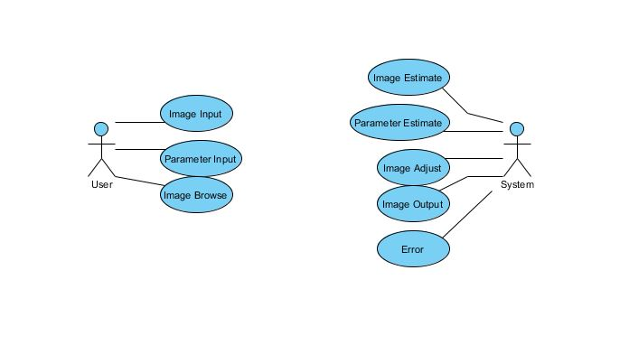
All implemented use cases have an associated Use Case Specification document. References to these documents can be found in the same directory.

3.1Architecturally-Significant Use Cases
The architecturally-significant use cases are those, that “exercise” the most critical parts of the system architecture and demonstrate the core system functionality. In this system they are:
Image Input: This use case allows user to input an image. When a develop group apply for using this system to get Loop stage images, this use case starts.
Basic Scenarios:
- User uploads an Loop stage image.
- System receives the image and estimates if the image is an image.

Parameter Input: This use case allows user to input parameters for the input image.
Basic Scenarios:
- The user inputs the parameters.
- The software receives the parameters.
Image Output: This use case allows the software to generate LDR images and show on the output device.
Basic Scenarios:
- User uploads an image.
- Software estimates if the image is Loop stage.
- User input the parameter(parameters).
- Software output an final image.
Actually, you can reference to the sequence diagrams and collaboration diagrams of these very important use cases in the analysis model.

4.Logical View
This section describes the architecturally significant parts of the design model, such as its decomposition into subsystems and packages. It describes the logical structure of the system. It starts from the overview of the architecture and then presents its key structure, behavioral elements and mechanisms.

4.1Overview
There are three dominant structures in the application design model:
- Logical decomposition of the system into three layers.
- The structure of the use case realizations derived from model templates of architectural mechanisms.
- The design mechanisms package contains the a pre-designed solution to a common problem.
The high-level diagram of above is showed below:
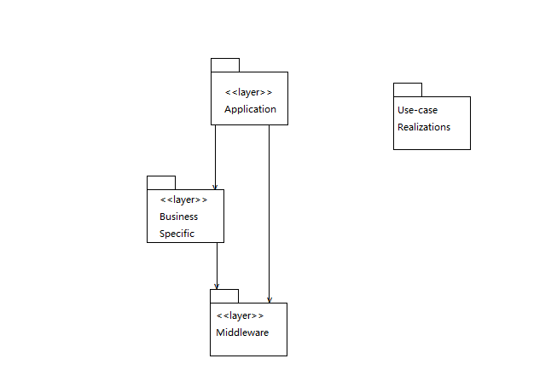

The three layers are introduced below:
- Middleware: The Caffe environment we need to use in this system.
- Business Specific: Including business components and one common elements and services component. The components in this layer have a high reusability.
- Application: This layer aim at special logic. It has a close relation to the presentation logic. The boundary classes are contained in this layer.

4.2Architecturally-Significant Model Elements:
Application:
Captcha Recognition User Interface
Business Specific:
Ubuntu 14.04
Anaconda
python2.7
matlab r2016b
Middleware:
Caffe environment

5.Process View
There is only one process in our software, so there is no need for additional deployment.

6.Deployment View
The deployment view of a system shows the physical nodes on which the system executes and the assignment of the system processed to the nodes. The diagram below shows the most typical deployment configuration used by the development team.
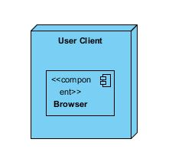

7.Implementation View
Organized by IDE , in this system, we use Ubuntu 14.04 + caffe + Anaconda + python2.7 + matlab r2016b.

